Cyber Crime and Digital Evidence
Prefetch Files
Week 35



Submitted by:
Full Name: Anish Adhikari
Orbund ID : 11147
Student ID : 24071101
Kathmandu, Nepal

4.2 Examine the data

- Which browser was used last on this computer and when? (Please provide the correct timestamp in the format: 2021-02-16 18:32:25 TIMEZONE)

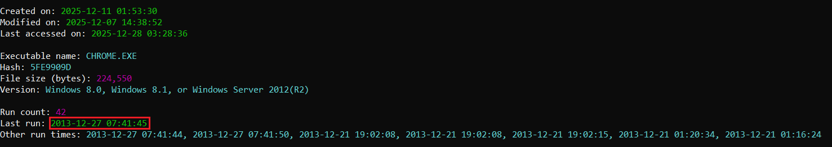
Ans: The last browser used on this computer was Chrome, and it was last run on
2013-12-27 07:41:45 (GMT).
Fig: Last run time of CHROME.EXE

- Did the user ever launch the Snipping Tool? If yes when? (Please provide timestamp, as previously)

Ans: Yes, the user launched the Snipping Tool. It was used only once, on 2013-12-21
01:00:33 (GMT).
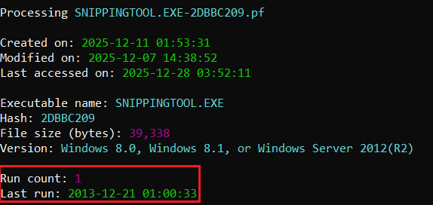
Fig : Execution of Snipping Tool

- Was GIMP launched the day it was installed? What day was it? (e.g. 2021-02-16 TIMEZONE)

Ans: Yes, GIMP was launched on the same day it was installed. GIMP was installed on
2013-12-20 21:37:17 GMT and was launched on the same day at 2013-12-20
21:38:38 GMT.

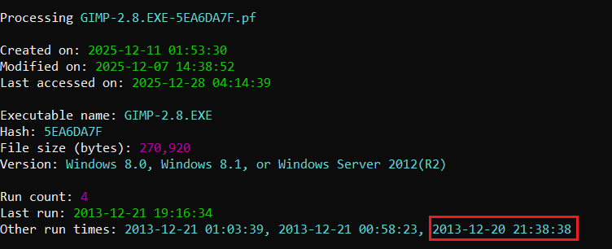
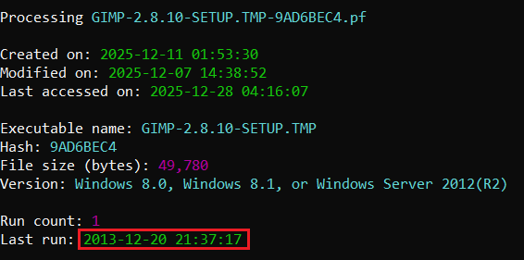
Fig: Installation Date of GIMP
Fig: Proof of GIMP-2.8.EXE executed on the same day

- How many times Google Chrome was run on this PC?

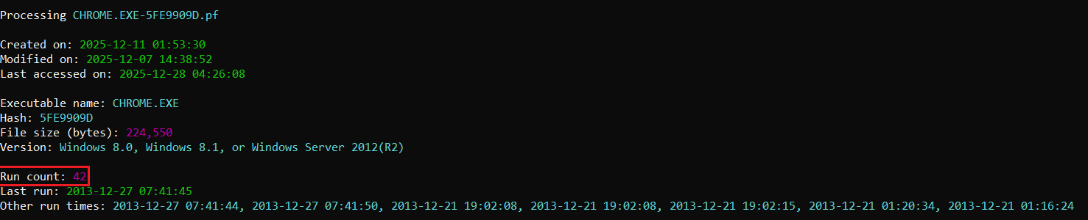
Ans: Chrome was executed a total of 42 times on this PC.
Fig: Run count of Chrome on PC

